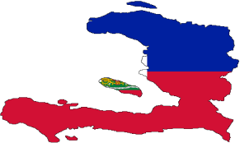
Empower Haiti
“Empowering Haitians to Help Haitians”
Haiti Mission Trip Information Packet – 2/18/17-2/24/17

- Facts – Haiti
- Weather
- Contact Information
- Goal of the Trip
- Costs
- Date Deadlines
- Transportation
- Itinerary*
- Housing
- Location(s)*
- Maps
- Before You Go
- Haitian Culture
- Safety
- Immunizations
- Communicating with Home
- Speaking Creole (Kreyol)
- Do’s and Don’ts
- Clothing
- Showering
- Food
- Luggage
- Money
- Passport
- Airport
- Items to Pack
- Snacks
- Items Needed by Empower Haiti

Empower Haiti

- FACTS
- Haiti occupies the western 1/3 of the island of Hispaniola (size of Maryland).
- It’s approximately 700 miles off the coast of Miami
- Average Haitian earns less than $3.00 per day
- More than ½ of the population lacks access to clean water
- Capital is Port-Au-Prince
- Population is approximately 10M
- Poorest country in the western hemisphere.
- 19th poorest country in the world.
- Over 400,000 children without parents.
- 12% of Haitian children die before their 1st birthday
- 1/3rd of children do not make it to their 5th birthday
- Voodoo is the official religion (1/2 population practices it).
- GDP per capita: $1,300
- Life Expectancy: 63
- Currency: Gourde
- Literacy rate: approximately 50%

- WEATHER
- Climate in Haiti is hot and humid (especially in the summer months)
- Dry Season – November to March
- Wet Season – April to October
- Can be cool in the mountains

- CONTACT INFORMATION
- Jesse Franklin
- turcrick@yahoo.com
- info@empowerhaitians.org
- 770-425-2253
- 770-789-1422
- 2377 Pine Mountain Road NW, Kennesaw 30152
- www.empowerhaitians.org

Empower Haiti

- GOALS OF THE TRIP
- Share the Gospel.
- Locate an orphanage that God leads us to, and to ultimately provide spiritual, financial and educational support for in the coming years.
- Come home and share the love you have developed for the Haitian people.

- COSTS
- $1,500 (Includes everything except souvenir/discretionary/tithing money)

- IMPORTANT DATES
- Commitment to go ASAP***(I monitor airfare fluctuations)***
- 08/15 - $200 Deposit
- 09/15 - $400
- 10/15 - $400
- 12/15 - $500
- Training/Meeting will begin 8 weeks prior to departure date of 2/18/17.

- TRANSPORTATION
- Carpool to Airport
- Driver(s) will be waiting upon our arrival in Port-Au-Prince
- Some driving in steep terrain
- Boat/Ferry
- ***Driving in Haiti is very hazardous***

Empower Haiti
- ITINERARY* (Subject to Change)
- Saturday 2/18:
- Depart Atlanta mid-afternoon
- Arrive at Hotel in Montrouis, Haiti (Approx. 1.5 hrs. North of Port-Au-Prince)
- Sunday 2/19:
- Local Church Service in Montrouis (AM)
- Visit orphanages around Montrouis, Haiti (Mountains) (PM)
- Monday 2/20:
- Leave for the Island of Gonaves via boat/orphanages (AM)
- Visit local community/orphanages (PM) (*overnight trip*)
- Tuesday 2/21:
- Leave for mainland Haiti (AM)
- School/Orphanage Montrouis (AM/PM)
- Wednesday 2/22:
- Trip to Port-Au-Prince to share the gospel at a women’s prison (AM)
- Work/Teach English at a school sponsored by Drops of Dew Ministries (PM)
- Thursday 2/23:
- Sightseeing/Hiking/Visiting with rural communities (Jericho Walk)
- Friday 2/24:
- Leave for Airport in Port-Au-Prince (Early AM)
- Back in Atlanta around Lunchtime (PM)

- HOUSING
- Hotel in Montrouis, Haiti OR
- Mission House in Montrouis, Haiti
- Hotel on the Island of Gonaives OR
- Mission House on the Island of Gonaives

- LOCATIONS
- Port-Au-Prince (See Maps)
- Montrouis, Haiti (See Maps)
- Island of Gonaives (See Maps)

Empower Haiti
- MAPS
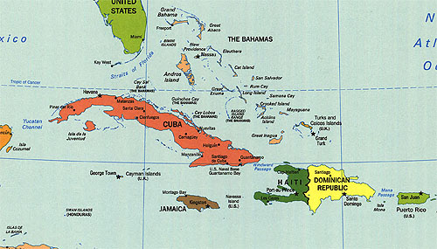
Florida
Haiti
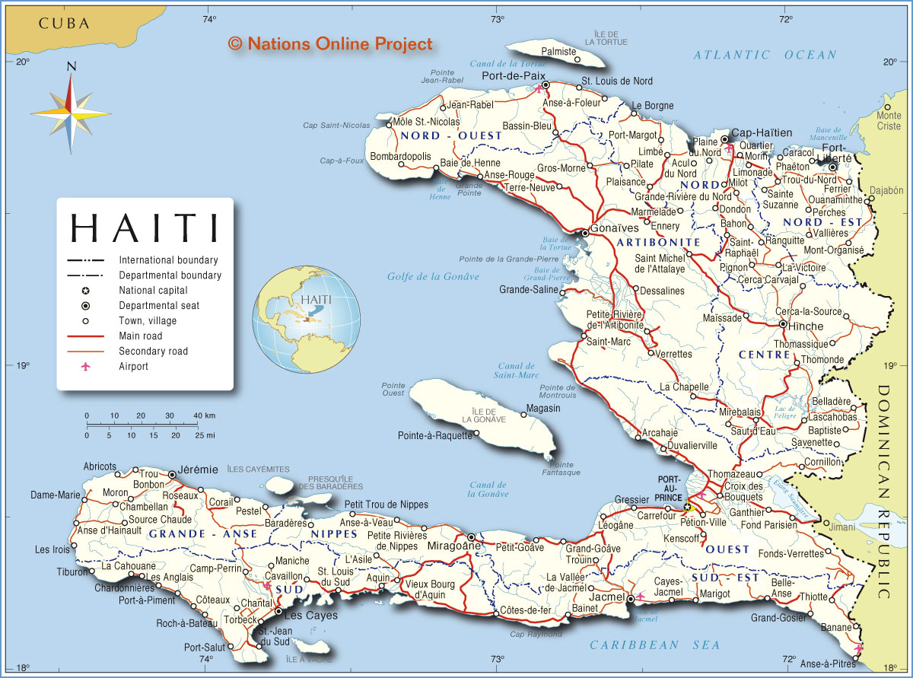
Port-Au-Prince
Gonaves
Montrouis
Empower Haiti
- BEFORE YOU GO
- Pray
- Get a Passport
- Immunizations

- HAITIAN CULTURE
- VooDoo – Many Haitians believe that they have no control over their destiny, so they take no responsibility to improve their situation in life.
- In most areas, men plant gardens, but women are thought of as the owners of harvests and, because they are marketers, typically they control the husband’s earnings.
- Women are expected to sit in modest postures
- Shorts are rare in Haitian culture (unless working in fields)
- Haitians can be offended by smoking.

- SAFETY
- Travel in groups of 2
- Murder rate is ½ that of the Dominican Republic
- Murder rate is barely ¼ of Jamaica
- One of the safest countries in the Caribbean.

- IMMUNIZATIONS (Recommended but not required)
- Typhoid
- Hepatitis A series
- Hepatitis B series
- Rabies
- Tetanus
- Malaria preventative
- Check with CDC on up-to-date immunization suggestions

- COMMUNICATING WITH HOME
- WiFi will be available in Hotel(s)***
- International Plan
- Email/Skype
- I will have my phone on me the whole time (770-789-1422).
Empower Haiti
- SPEAKING CREOLE
- HaitiHub
- Creole Made Easy
- We will practice simple phrases as we get closer to the trip.

- DO’S & DON’TS
- DO’s. . .
- Be prepared for a change in plans. Rain, civil unrest and/or breakdowns in equipment can
cause planned activities to be rescheduled or canceled.
- Keep your passport on you at all times. Also, have a copy of your
passport separate from your real passport.
- Be considerate of your fellow team members in being prompt for outings.
- Drink lots of water. You will dehydrate quickly in Haiti.
- Be sensitive to the Haitian culture when dressing to go into their space.
- Be frugal in use of resources (e. g., water, electricity). These are precious in Haiti.
- Remember you are a representative of our Lord and Savior at all times.
- DON’TS
- Drink any water except what you get at the hotel (DO NOT DRINK OUT OF THE BAGGED WATER).
- Rinse your toothbrush in tap water after brushing. Keep a bottle of purified water
handy for this purpose, or just dry with paper.
- Eat anything except what you bring from the U. S. or what is served at hotel/mission house.
- Separate yourself from the team. In any case, do not go unaccompanied into questionably safe areas.
- Give money or treats to beggars. You may be bombarded with youngsters saying,
“Give me one dollar” beginning at your arrival at the airport.
- Eat in front of Haitians. Most eat only one simple meal per day, and they will
be hungry when you are with them. Eating during outings may have to be portable
snack items and eaten off-schedule or while traveling to or from the destination.
- Give out things directly or openly to new-found friends in Haiti.
- Be reluctant to ask questions!
- Give out personal contact information (even to translators)!

- CLOTHING
- Summer clothing is appropriate
- Women should wear a skirt or a sundress to signify that you are a Christian Missionary
- Capri’s and walking shorts are acceptable
- Men can wear shorts/slacks when appropriate (ie church)
- Sandals/tennis shoes can be worn
- DO NOT wear any jewelry that has sentimental value and/or large monetary value
Empower Haiti
- SHOWERING
- Unscented toiletries (scented items attract bugs)

- FOOD
- Breakfast and Dinner while in Haiti will be included
- Encouraged to bring personal snacks
- Clean drinking water will be provided
- Recommend bringing a sports bottle
- You are responsible for meals during travel to and from Haiti

- LUGGAGE
- All items to be donated should be checked
- You should be able to fit your clothing and personal items in a rolling carryon
- Be mindful of toiletry items regarding security

- MONEY
- Approximately $60 (Gourdes) = $1 (US Dollar)
- $1 (Haitian dollar) = $5 (Gourdes)
- $12 (Haitian dollars) = $1 (US Dollar)
- Credit Cards are only accepted in some places (ie Airport)
- DO NOT take any bills over $10.00.
- $1’s and $5’s are suggested.

- PASSPORT
- It is required to have a passport valid for at least 6 months following the return of travel to Haiti
- Visit: travel.state.gov/passport for more information
- If you do not have a passport, start the process asap

- AIRPORT
- Upon arrival, there will be many people waiting outside to “help you” with your bags
- Can be very overwhelming
- This is not a free service
- Some people wait there all day just for the chance to make money
- Keep your hands on your luggage at all times (outside of the airport)

Empower Haiti
- ITEMS TO PACK
- Cash in denominations under $10’s
- Unscented soap, shampoo, location
- Bug spray (bracelets)
- Flashlight
- Toilet Paper (1 roll, just in case)
- Flip Flops/Sandals/Shoes
- Summer Clothes
- Light Windbreaker
- Swim Suit
- Antibacterial Hand Gel
- Water Bottle
- Sunglasses
- Sunscreen

- SNACKS
- Trail Mix
- Beef Jerky
- Granola Bars
- On-the-Go Peanut Butter

- ITEMS NEEDED
- Mission Trip Application
- Volunteer Release Form
- Emergency Contact Information Form
- Medical Information Form
- Acknowledgment Page

Empower Haiti
“Empowering Haitians to Help Haitians”
2017 Haiti Mission Trip Information/Details

Goal: Starting point is to find that one unsupported orphanage that God calls us to support/spread the Gospel to the unreached.

Dates: 02/18/2017 – 02/24/2017
- Depart ATL (2/18): 4:30 PM – Arrive PAP: 7:38 PM
- Depart PAP (2/24): 8:30 AM – Arrive ATL: 11:44 AM

Anticipated Cost: $1,250.00 – Includes:
- Airfare
- Food (Breakfast & Dinner)
- Lodging
- Transportation
- Translator(s)
- Trip Insurance

Payment Dates:
- 8/15/16 - $150 Deposit
- 9/15/16 - $350
- 10/15/16 - $350
- 11/15/16 - $400

Anticipated Itinerary (*Subject to change based on political environment; presently a lot of rioting in the Montrouis area):
Saturday 2/18
- Arrive at Hotel in Montrouis, Haiti
Sunday 2/19
- Local Church Service in Montrouis (AM)
- Visit unsupported orphanages around Montrouis, Haiti (Mountains) (PM)
Monday 2/20
- Leave for the Island of Gonaves (AM)
- Visit unsupported orphanages (overnight trip) (PM)
Tuesday 2/21
- Leave for mainland Haiti (AM)
- Visit unsupported orphanages in Montrouis (PM)

Empower Haiti

Wednesday 2/22
- Trip to Port-Au-Prince to visit a women’s prison (AM/PM)
Thursday 2/23
- Sightseeing/Hiking/Visiting with local communities (Jericho Walk)
Friday 2/24
- Leave for Port-Au-Prince (AM)
- Arrive in Atlanta (Early PM)

Empower Haiti

Mission Trip Application

Personal Information:

Name:

Address:

(2)

Phone:

Email:

Date of birth:

Health Information (confidential):

Describe your general health condition:

Are you taking any medication? If so, what?

Allergies:

Blood type:

Family Physician:

Family Physician Phone #:

Medical Insurance Company for trip:

Medical Insurance Contact #:

Emergency Contact Person:

Emergency Contact Phone #:

Relationship:

Empower Haiti
Other Important Questions:

Have you traveled to Haiti? If so, when and where?

What is your primary motivation for this trip?

Passport #:

Passport Expiration Date:

Any other helpful comments or suggestions?

IN SIGNING BELOW, I ACKNOWLEDGE THE FOLLOWING:

The above information is true to the best of my knowledge.

Empower Haiti, Inc. and/or volunteer staff cannot be held responsible for any accident, injury or death that could occur while in or traveling to/from Haiti.

NAME:

SIGNATURE:

DATE:

Please return:
Empower Haiti, Inc.
Jesse Franklin
2377 Pine Mountain Road NW
Kennesaw, GA 30152
info@empowerhaitians.org
Empower Haiti

Volunteer Release Form

We are delighted with your decision to travel with us, and we are more than willing to help you with all of the arrangements. However, any travel is accompanied by certain risks. Our organization is comprised entirely of volunteers like you.

Please sign and date this document and return it to Empower Haiti, Inc. acknowledging this notification, releasing us from liability, and indemnifying us from claims against us arising from your activities. We must receive a signed copy of this letter before we can continue to plan your trip.

The undersigned hereby acknowledges receiving this letter, and acknowledges the risks assumed by volunteers of Empower Haiti, Inc., it’s officers, directors, members and all other persons and organizations working on its behalf from any and all loss, liability, actions, claims and demands of any nature, past, present or future, that may result from or be in any way related to the undersigned’s activities conducted under the auspices of Empower Haiti, Inc..

NAME: (printed)

SIGNATURE:

DATE SIGNED:

Please return this release with your trip application
Empower Haiti, Inc.
Jesse Franklin
2377 Pine Mountain Road NW
Kennesaw, GA 30152
info@empowerhaitians.org

Empower Haiti

Emergency Contact Information Form

Volunteer Emergency Contact Information:

Please provide us with the name and contact information of the person we should contact in case of an emergency.

Name:

Relationship:

Daytime Phone:

Evening Phone:

Home Address:

Email:

Additional Information:

Please return this form with your trip application:
Empower Haiti, Inc.
Jesse Franklin
2377 Pine Mountain Road NW
Kennesaw, GA 30152
info@empowerhaitians.org

Empower Haiti

Medical Information Form

Provide us with the following medical information in case of an emergency:

Name:

Existing Medical Conditions:

Allergies:

Blood Type:

List all medications you are currently taking:

Doctors Name:

Phone Number of Doctor:

Any Additional Information:

Empower Haiti

Acknowledgement Form

A mission trip can be a very rewarding experience. However, if a volunteer goes to a third world country unprepared, it can make for an unpleasant experience. It is vital that all volunteers read and acknowledge that they understand the risks, requirements and expectations of travel to Haiti.

After reading the mission packet please sign the following document and return to Empower Haiti along with the release of liability, emergency contact information and medical information form. Please also send a color copy of your passport and a copy of your medical insurance card.

The undersigned hereby acknowledges, receiving this Mission packet, and acknowledges that they have read and understand all requirements and expectations listed herein.

Name:

Signature:

Date Signed:

Please return Acknowledgement page with trip application:
Empower Haiti, Inc.
Jesse Franklin
2377 Pine Mountain Road NW
Kennesaw, GA 30152
info@empowerhaitians.org

